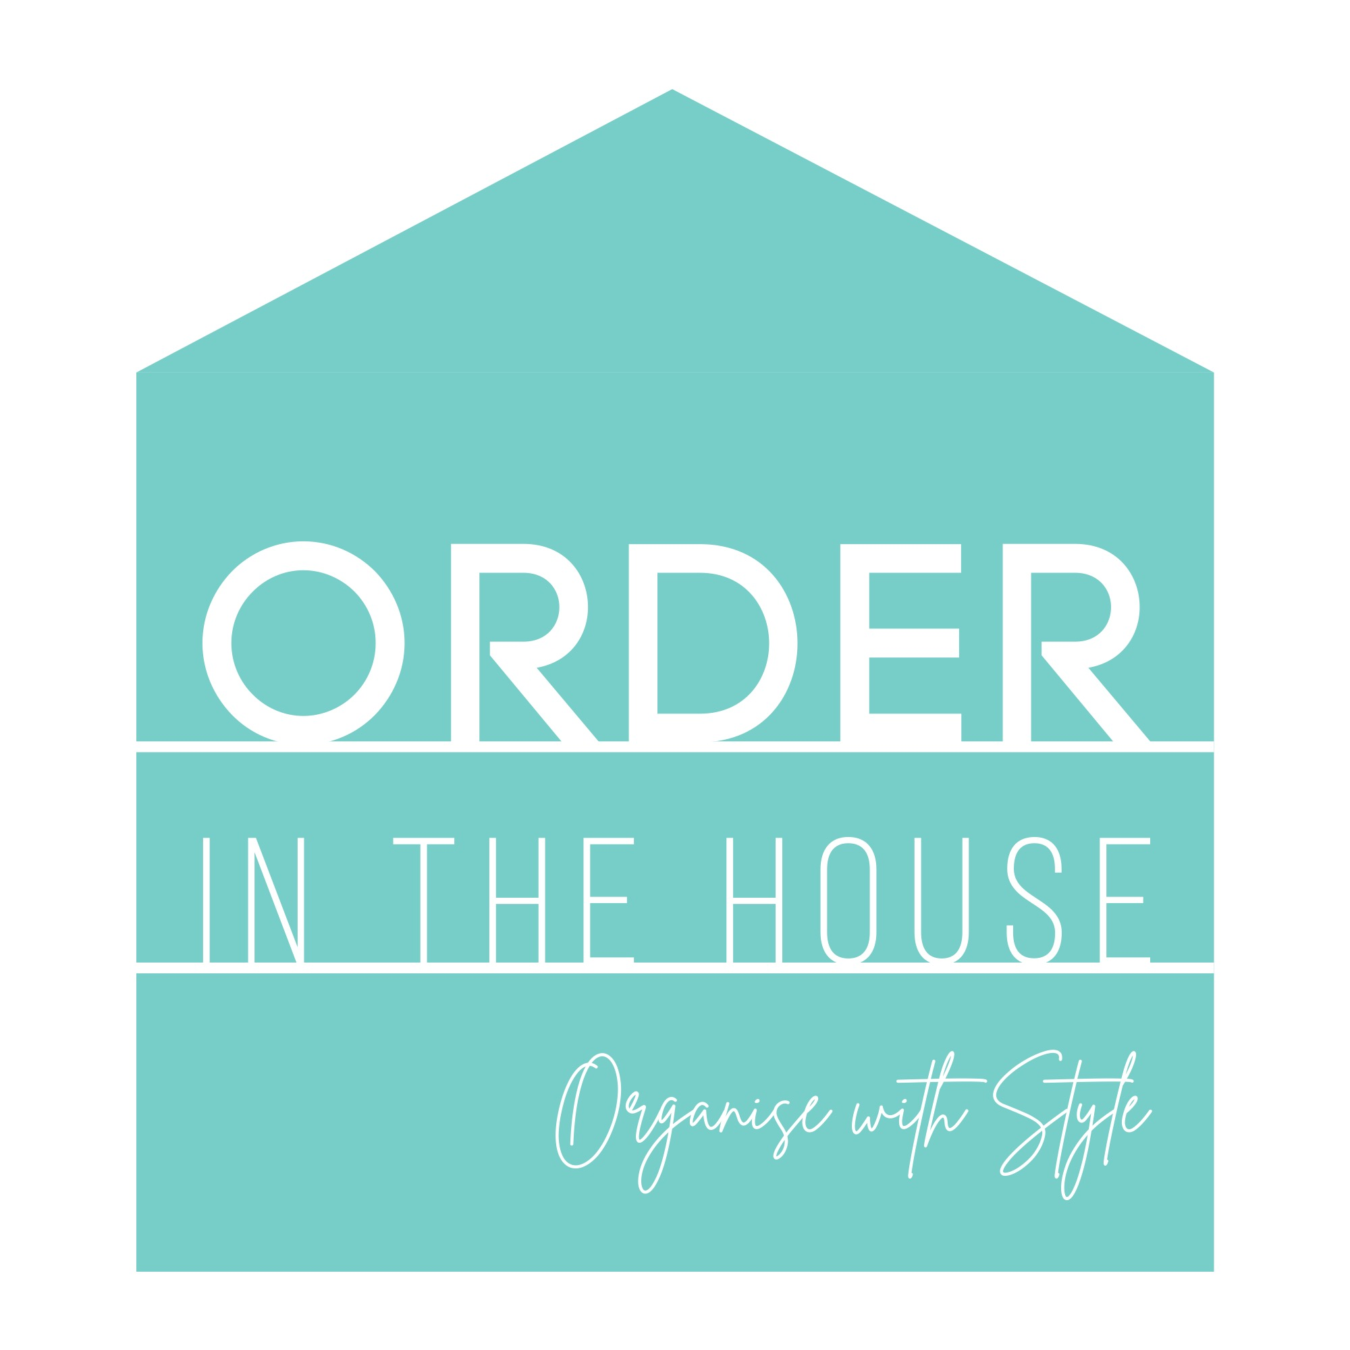

This Affiliate Disclosure is provided by Order in the House NI (“Order in the House”, “OITH” or “we” or “our”), and applies to www.orderinthehouseni.com, including, without limitation, both mobile and online versions of our websites, email and social channels (collectively, referred to herein as the “Site”), and is provided for the purpose of disclosing Order in the House’s financial relationship with affiliates, advertisers, sponsors and other third parties that appear on the Site (collectively, referred to herein as “Affiliates”).

This Affiliate Disclosure has been posted on the Site or has otherwise been linked to in a post or article since Order in the House sells and thus receives monetary and other forms of compensation from Affiliates for various insertion orders and promotional campaigns that we feature on the Site. Thus, there is paid connection between each product or service mentioned, reviewed or recommended on this Site and the Affiliate (i.e., the owner of that third-party product or service). If you ultimately decide to purchase a product or service mentioned on the Site, Order in the House may receive additional compensation from that purchase from the Affiliate. Every effort has been made by Order in the House to provide true and accurate statements in regard to any and all products or services mentioned, however Order in the House is not responsible for any changes in price changes or descriptions on any affiliate or third-party websites.

Further, the Site posts or otherwise promotes content, including editorial content, which may feature third-party products and services (the “Affiliate Products”) and which may link to third-party owned and operated websites where you can purchase Affiliate Products. The content featuring Affiliate Products from multiple brands will always be editorially selected, even though we may receive compensation in connection with your purchase of Affiliate Products as outlined above, we still seek to provide our honest opinions, findings, beliefs, and experiences as they relate to the Affiliate Products that are featured on the Site.
We also receive monetary and other forms of compensation from Affiliates to publish supported (paid-for editorial content) campaigns on the Site. When this is the case, the content is clearly marked as ‘supported’, ‘AD’, and/or ‘in partnership with’ so you’ll always know which content has been created with the brand and which has not.
Please contact us at info@orderinthehouseni should you have any questions or concerns.

